LIVE BRIDGE: REAL TIME EMERGENCY RESPONSE SYSTEM
21CSP302L- PROJECT
Submitted by
ALOK SINGH [RA2311056010304]
SHREYANSH VINAY[RA2311056010307]
ROHAN SHAW[RA2311056010295]

Under the Guidance of

A.Siva Kumar

Assistant professor
Department of Data Science and Business System

in partial fulfillment of the requirements for the degree of

BACHELOR OF TECHNOLOGY

in

COMPUTER SCIENCE ENGINEERING

with specialization in DATA SCIENCE


DEPARTMENT OF DATA SCIENCE AND

BUSINESS SYSTEMS
SRM INSTITUTE OF SCIENCE AND TECHNOLOGY

KATTANKULATHUR- 603 203

MAY 2026


Department of Computational Intelligence

SRM Institute of Science & Technology

Declaration Form

Degree/ Course : B. Tech/Data Science

Student Name : Alok Singh, Shreyansh Vinay, Rohan Shaw

Registration Number : RA2311056010304, RA2311056010307, RA2311056010295

Title of Work : REAL TIME EMERGENCY RESPONSE SYSTEM

We hereby certify that this assessment compiles with the University’s Rules and Regulations relating to Academic misconduct and plagiarism, as listed in the University Website, Regulations, and the Education Committee guidelines.

We confirm that all the work contained in this assessment is our own except where indicated, and that We have met the following conditions:

- Clearly referenced / listed all sources as appropriate
- Referenced and put in inverted commas all quoted text (from books, web, etc)
- Given the sources of all pictures, data etc. that are not my own
- Not made any use of the report(s) or essay(s) of any other student(s) either past or present
- Acknowledged in appropriate places any help that I have received from others (e.g. fellow students, technicians, statisticians, external sources)
- Compiled with any other plagiarism criteria specified in the Course handbook / University website
We understand that any false claim for this work will be penalized in accordance with the University policies and regulations.
DECLARATION:
We are aware of and understand the University’s policy on Academic misconduct and plagiarism and We certify that this assessment is our own work, except where indicated by referring, and that We have followed the good academic practices noted above.

Alok Singh Shreyansh Vinay Rohan Shaw
(RA2311056010304) (RA2311056010307) (RA2311056010295)



SRM INSTITUTE OF SCIENCE AND TECHNOLOGY KATTANKULATHUR – 603 203

BONAFIDE CERTIFICATE

Certified that 21CSP302L - Project report titled “REAL TIME EMERGENCY RESPONSE SYSTEM” is the bonafide work of “Alok Singh [RA2311056010304], Shreyansh Vinay [RA2311056010307], Rohan Shaw [RA2311056010295]” who carried out the project work under my supervision. Certified further, that to the best of my knowledge the work reported herein does not form any other project report or dissertation on the basis of which a degree or award was conferred on an earlier occasion on this or any other candidate.

SIGNATURE  - Siva Kumar  ASSISTANT PROFESSOR  DEPARTMENT OF  DATA SCIENCE &  BUSINESS SYSTEM |  | SIGNATURE  Dr. KAVITHA V  PROFESSOR &HEAD  DEPARTMENT OF  DATA SCIENCE &  BUSINESS SYSTEMS

EXAMINER 1 EXAMINER 2

ACKNOWLEDGEMENTS

We express our humble gratitude to Dr. C. Muthamizhchelvan, Vice-Chancellor, SRM Institute of Science and Technology, for the facilities extended for the project work and his continued support.

We extend our sincere thanks to Dr. Leenus Jesu Martin M, Dean-CET, SRM Institute of Science and Technology, for his invaluable support.

We wish to thank Dr. Revathi Venkataraman, Professor and Chairperson, School of Computing, SRM Institute of Science and Technology, for her support throughout the project work.

We encompass our sincere thanks to, Dr. M. Pushpalatha, Professor and Associate Chairperson - CS, School of Computing and Dr.C. Lakshmi, Professor and Associate Chairperson -AI, School of Computing, SRM Institute of Science and Technology, for their invaluable support.

We are incredibly grateful to our Head of the Department, Dr. Kavitha V, SRM Institute of Science and Technology, for her suggestions and encouragement at all the stages of the project work.

We want to convey our thanks to our Project Coordinators, Panel Head, and Panel Members Department of Computational Intelligence, SRM Institute of Science and Technology, for their inputs during the project reviews and support.

We register our immeasurable thanks to our Faculty Advisor Dr. Dhanalakshmi J, Department of Data Science and Business Systems, SRM Institute of Science and Technology, for leading and helping us to complete our course.

Our inexpressible respect and thanks to our guide, A. Siva Kumar Department of Data Science and Business Systems, SRM Institute of Science and Technology, for providing us with an opportunity to pursue our project under his mentorship. He provided us with the freedom and support to explore the research topics of our interest. His passion for solving problems and making a difference in the world has always been inspiring.

We sincerely thank all the staff members of Data Science and Business Systems, School of Computing, S.R.M Institute of Science and Technology, for their help during our project. Finally, we would like to thank our parents, family members, and
friends for their unconditional love, constant support and encouragement

ALOK SINGH (RA2311056010304)
SHREYANSH VINAY (RA2311056010307)
ROHAN SHAW (RA2311056010295)

ABSTRACT

The Emergency Response System is a real-time web-based application designed to improve emergency handling by enabling faster communication between victims, responders, and hospitals. The system integrates live GPS tracking, real-time communication using WebSockets, and hospital coordination features to ensure efficient emergency management.

The application allows victims to send SOS alerts along with their location, which is instantly received by dispatchers and nearby responders. Responders can accept requests, share live location updates, and communicate with victims via chat. Hospitals can monitor incoming emergencies and prepare accordingly.

The system is built using React for the frontend, Node.js with Express for backend services, PostgreSQL for database management, and Socket.io for real-time communication. This project aims to reduce response time, improve coordination, and ultimately save lives by leveraging modern web technologies..

The proposed system emphasizes scalability, reliability, and ease of use by incorporating a modular architecture and user-friendly interface. It ensures secure data handling and seamless communication between all entities involved in emergency scenarios. By utilizing real-time data synchronization and efficient backend processing, the system minimizes delays and enhances decision-making during critical situations. This solution not only improves operational efficiency but also has the potential to significantly reduce casualties by enabling faster and more coordinated emergency responses.

.

TABLE OF CONTENTS
ABSTRACT v

TABLE OF CONTENTS vi

LIST OF FIGURES vii

LIST OF TABLES viii

ABBREVIATIONS ix

CHAPTER TITLE PAGE
NO. NO.

1 INTRODUCTION 1
  - Introduction to Project 2
  - Problem Statement and Description 3
  - Motivation 4
  - Sustainable Development Goal of the Project 5
2 LITERATURE SURVEY 6
2.1 Overview of the Research Area 7
2.2 Existing Models and Frameworks 8
2.3 Limitations Identified from Literature Survey (Research Gaps) 11
2.4 Research Objectives 12
2.5 Product Backlog (Key user stories with Desired outcomes) 13
2.5 Plan of Action (Project Road Map) 15

3 SPRINT PLANNING AND EXECTION METHODOLOGY 21
3.1 SPRINT I 21
3.1.1 Objectives with user stories of Sprint I 23
3.1.2 Functional Document 25
3.1.3 Architecture Document 28
3.1.4 Outcome of objectives/ Result Analysis 29
3.1.5 Sprint Retrospective 30
3.2 SPRINT II 31
3.2.1 Objectives with user stories of Sprint II 32
3.2.2 Functional Document 33
3.2.3 Architecture Document 34
3.2.4 Outcome of objectives/ Result Analysis 35
3.2.5 Sprint Retrospective 36

4 RESULTS AND DISCUSSIONS 37
4.1 Project Outcomes (Performance Evaluation, Comparisons, Testing Results ) 38
5 CONCLUSION AND FUTURE ENHANCEMENT 39
REFERENCES 40
APPENDIX 41
A CODING 43
B CONFERENCE PUBLICATION 48
C JOURNAL PUBLICATION 50
D PLAGIARISM REPORT 51

LIST OF FIGURES

CHAPTER NO | TITLE | PAGE NO.
3.1.1 | MS Planner Board of The Emergency Response System
3.1.2 | Functional Document
3.1.3 | Architecture Document
3.1.4 | Sprint 1 Outcomes
3.2.3 | Architecture Document
3.2.4 | Sprint 2 Outcomes

LIST OF TABLES

Section No. | Title | Page No.
2.4 | Research Objectives
3.1.1 | Objectives with User Stories of Sprint I
3.2.1 | Objectives with User Stories of Sprint II
3.2.2 | Functional Document
4 | Result and Discussion

ABBREVIATIONS

AES Advanced Encryption Standard
ANN Artificial Neural Network
CNN Colvonutional Neural Network
CSS Cascading Style Sheet
CV Computer Vision
DB Database
DNA Deoxyribo Neucleic Acid
GCP Google Cloud Platform
HAM Human Against Machine
HTML Hyper Text Markup Language
HTTP Hyper Text Transfer Protocol
JS JavaScript
KNN K Nearest Neighbours
MNIST Modified National Institute of Standards and Technology
PWA Progressive Web App
RNA Ribo Neucleic Acid
ROC Receiver Operating Characteristic
SASS Syntactically Awesome Style Sheets

CHAPTER 1

INTRODUCTION

  - Introduction to project

Emergency situations such as accidents, medical crises, or natural disasters demand immediate attention and rapid response. In such critical moments, even a small delay can lead to severe consequences, including loss of life. Traditional emergency response systems primarily rely on phone calls and manual coordination, which often results in slower communication and inefficiencies in dispatching help.

With advancements in technology, especially in web development and real-time communication, there is an opportunity to enhance emergency management systems significantly. This project proposes a Real-Time Emergency Response System that integrates modern tools such as GPS tracking, WebSockets, and cloud-based databases to provide an efficient and reliable platform for handling emergencies.

The system ensures that victims can quickly send alerts, responders can act immediately, and hospitals can prepare in advance. By bridging the communication gap between all stakeholders, the system aims to provide a faster, smarter, and more effective emergency response mechanism.

1.2 Problem Statement and Description
Despite the existence of emergency services, several challenges persist in current systems. One of the major issues is the lack of real-time coordination between victims, responders, and medical facilities. Emergency calls are often routed through centralized systems that may become overloaded, leading to delays in response.

Another major concern is the absence of live location tracking, which makes it difficult for responders to reach the exact location quickly. Additionally, there is minimal communication between hospitals and emergency responders, which results in unprepared medical facilities when patients arrive.

This project addresses these issues by developing a system that enables instant communication, live tracking, and coordinated response. It provides a centralized platform where all participants can interact efficiently, ensuring that emergency situations are handled with minimal delay and maximum effectiveness.

1.3 Motivation
The primary motivation behind this project is the increasing need for efficient emergency management systems in modern society. With rising population density and urbanization, the number of emergencies has significantly increased, making it essential to have a system that can handle such situations effectively.

Personal experiences, news reports, and case studies have shown that delays in emergency response often lead to tragic outcomes. This inspired the development of a system that leverages technology to reduce response time and improve coordination.

Furthermore, the availability of technologies such as real-time communication frameworks, mapping services, and scalable backend systems makes it feasible to build a robust emergency response platform. This project aims to utilize these technologies to create a solution that can potentially save lives and improve public safety.

1.4 Sustainable Development Goal of the Project
This project aligns with global sustainable development goals, particularly SDG 3: Good Health and Well-being, which focuses on ensuring healthy lives and promoting well-being for all. By improving emergency response times and coordination, the system contributes to better healthcare outcomes.

Additionally, the project supports SDG 9: Industry, Innovation, and Infrastructure by promoting the use of innovative technologies in critical infrastructure systems. The implementation of a real-time emergency response system demonstrates how digital transformation can enhance essential services and improve societal well-being..

CHAPTER – 2
LITERATURE SURVEY

2.1 Overview of the Research Area
The field of emergency response systems has evolved significantly with the integration of digital technologies. Earlier systems relied heavily on manual processes and telephone-based communication, which often led to inefficiencies. With the introduction of GPS tracking, mobile applications, and cloud computing, modern systems have become more dynamic and responsive.

Recent research focuses on the use of real-time data processing, artificial intelligence, and Internet of Things (IoT) devices to enhance emergency management. These technologies enable faster decision-making, improved resource allocation, and better communication among stakeholders.

Multi-task learning has emerged as a natural evolution in this space, recognizing that segmentation and classification are not orthogonal problems but complementary ones sharing a common visual evidence base. Research in this direction has demonstrated that joint optimization consistently outperforms single-task baselines when the shared representation is carefully designed and the training strategy accounts for competing gradient dynamics between tasks.

2.2 Existing Models and Frameworks
Several systems have been developed to address emergency response challenges. Traditional ambulance dispatch systems rely on centralized call centers that coordinate with responders. GPS-based applications allow users to share their location during emergencies, but they often lack integration with emergency services.

Modern frameworks include mobile-based emergency apps and smart city solutions that integrate sensors and real-time data. However, many of these systems are limited in scope and do not provide a complete solution that includes victims, responders, and hospitals on a single platform.

  - Limitations Identified from Literature Survey (Research Gaps)

Recent advancements in emergency response systems have focused on the integration of Artificial Intelligence (AI), geolocation technologies, and Internet of Things (IoT) devices to enhance efficiency and reduce response time. Existing research primarily aims to improve victim localization, automate emergency detection, and optimize dispatch mechanisms.

Despite advancements, existing systems still have several limitations. Many applications do not support real-time communication, which is crucial during emergencies. Others lack scalability, making them unsuitable for large-scale deployment.

Another major gap is the lack of integration between different stakeholders. Most systems focus only on one aspect, such as tracking or communication, but fail to provide a comprehensive solution. This project aims to bridge these gaps by developing an integrated platform that addresses all key aspects of emergency response.

Most studies utilize GPS-enabled mobile devices to determine the real-time location of victims. Pathfinding
algorithms such as Dijkstra’s Algorithm and A* are commonly implemented to identify the shortest and fastest routes for emergency vehicles. This significantly improves dispatch efficiency and reduces travel time.

A significant portion of the literature relies on IoT-based hardware solutions. These include sensors such as accelerometers (e.g., MPU6050) for accident detection and wearable devices for monitoring physiological parameters like heart rate. These systems automatically trigger alerts without requiring manual intervention.

.

.

2.3 Research Objectives:

The primary objective of this project is to design and develop a real-time emergency response system that enables users to send SOS alerts instantly along with their location details. The system aims to incorporate live GPS tracking to accurately monitor the movement of victims and responders during emergency situations. Another key objective is to establish a seamless real-time communication mechanism using modern technologies, allowing effective interaction between victims, responders, dispatchers, and hospitals. The project also focuses on developing a centralized dashboard that enables dispatchers to monitor multiple emergencies simultaneously and manage resources efficiently.

In addition, the system aims to enhance coordination with hospitals by providing timely information about incoming emergencies so that necessary preparations can be made in advance. Ensuring low latency and high performance is another critical objective, as quick response time is essential in emergency scenarios. The project also emphasizes building a scalable and secure architecture capable of handling multiple users while protecting sensitive data. Furthermore, improving user experience by designing a simple and intuitive interface is considered an important goal.

The project also aims to evaluate the system based on key performance metrics such as response time, reliability, and tracking accuracy. Another objective is to reduce dependency on traditional call-based emergency systems by introducing a more efficient digital solution. Finally, the system is designed with future enhancements in mind, such as the integration of artificial intelligence and advanced analytics to further improve emergency handling and decision-making processes.

2.4 Product Backlog (Key user stories with Desired outcomes)
Below are some of the user stories which represent the functional requirements of the MultiTaskUNet system from the viewpoints of the respective stakeholders and their desired outcomes.

User Story ID | User Story | Desired / Expected Outcome
US-01 | As a victim, I want to send an SOS alert with my current location so that help can reach me quickly during an emergency. | The system instantly sends the alert with accurate GPS location to nearby responders and dispatchers in real time.
US-02 | As a victim, I want to share my live location continuously so that responders can track me easily. | Live tracking is enabled, allowing responders to monitor movement and reach the exact location without delay.
US-03 | As a responder, I want to accept or reject emergency requests so that tasks can be managed efficiently. | Responders can accept requests, and the system assigns the case while notifying other responders.
US-04 | As a responder, I want to navigate to the victim’s location using maps so that I can reach faster.. | Integrated map system provides optimal route and real-time navigation support..
US-05 | As a dispatcher, I want to monitor all ongoing emergencies so that I can manage resources effectively.. | A centralized dashboard displays all active cases with live updates and status tracking.
US-06 | As a system admin, I want to manage users and data securely so that the system remains reliable and safe.. | Secure authentication and role-based access control ensure data protection.
US-07 | As a user, I want to communicate with responders via chat so that I can provide additional information. | Real-time chat system enables smooth communication between victim and responder.

2.5 Plan of Action (Project Road Map)
The development of the Real-Time Emergency Response System is carried out in a structured and phased manner to ensure systematic progress, efficient resource utilization, and timely completion of the project. Each phase focuses on specific objectives and deliverables, enabling the team to build, test, and refine the system incrementally.

Phase 1: Requirement Analysis and Planning
The first phase involves understanding the problem domain and gathering detailed requirements for the system. This includes identifying the needs of different stakeholders such as victims, responders, dispatchers, and hospitals. Functional and non-functional requirements are analyzed, and feasibility studies are conducted to determine the practicality of the proposed solution. A clear project scope is defined, and the development plan is outlined. This phase ensures that the team has a solid foundation before proceeding to design and implementation.

Phase 2: System Design and Architecture
In this phase, the overall system architecture is designed based on the requirements gathered. The project adopts a client-server architecture, where the frontend, backend, database, and real-time communication layers are clearly defined. User interface designs and wireframes are created to visualize the application flow. Database schema design is also performed to structure the storage of user data, emergency records, and location information. This phase ensures that the system design is scalable, efficient, and easy to maintain.

Phase 3: Frontend Development
The frontend of the application is developed using modern web technologies to provide an interactive and user-friendly interface. Key components such as login pages, dashboards, emergency alert buttons, maps, and chat interfaces are implemented. Special attention is given to usability and responsiveness to ensure that the application can be used effectively in critical situations. This phase focuses on creating a seamless user experience for all stakeholders.

Phase 4: Backend Development
The backend development phase involves building the server-side logic using Node.js and Express. APIs are developed to handle user authentication, emergency alerts, data retrieval, and communication between different components of the system. The backend is also responsible for processing requests, managing sessions, and ensuring secure data handling. Integration with the PostgreSQL database is completed in this phase to store and manage all application data efficiently.

Phase 5: Real-Time Communication Integration
This phase focuses on implementing real-time features using technologies such as Socket.io. Live communication is enabled between victims, responders, and dispatchers, allowing instant updates and notifications. Features such as live location tracking, real-time alerts, and chat functionality are integrated into the system. This phase is crucial as it ensures immediate response and coordination during emergencies.

Phase 6: Testing and Debugging
After development, the system undergoes rigorous testing to ensure functionality, performance, and reliability. Various testing methods such as unit testing, integration testing, and system testing are performed. Bugs and errors are identified and resolved to improve system stability. Special attention is given to testing real-time features and handling multiple simultaneous users to ensure the system performs well under different scenarios.

Phase 7: Deployment and Evaluation
In the final phase, the system is deployed in a suitable environment for real-world usage. Performance is evaluated based on metrics such as response time, accuracy of tracking, and system reliability. Feedback is collected to identify areas for improvement. Documentation is completed, and the final report is prepared. This phase ensures that the system is ready for practical implementation and future enhancements.

CHAPTER- 3

SPRINT PLANNING AND EXECTION
METHODOLOGY

3.1 Sprint Planning and Execution
The development of the Real-Time Emergency Response System is carried out using an Agile-based sprint methodology. The project is divided into multiple sprints, where each sprint focuses on developing and delivering a specific set of functionalities. This approach ensures incremental development, continuous testing, and timely completion of the project.

During the sprint planning phase, the requirements are analyzed and prioritized based on the product backlog. The major functionalities such as user authentication, SOS alert system, real-time tracking, and communication features are broken down into smaller tasks. These tasks are then assigned to team members with clearly defined objectives and timelines.

The sprint execution phase involves implementing the planned tasks and integrating different components of the system. Continuous monitoring is performed to track the progress of each task. Regular discussions and reviews are conducted to identify issues and make necessary improvements. This iterative process ensures that the system is developed efficiently and meets the desired requirements.

3.1.1 Objectives with user stories of Sprint I
To develop the core structure of the system including backend setup, database integration, and basic frontend interface.

Tasks Performed:
• Setup of server using Node.js and Express
• Design and integration of PostgreSQL database
• Development of basic frontend using React
• Implementation of user authentication module

Outcome:

At the end of this sprint, the basic framework of the system is established. The application is capable of handling user login and managing core functionalities.

Sprint I — Detailed User Stories

S.NO | Detailed User Stories
US #1 | As a user (victim/responder/dispatcher), I want to register and log in to the system securely so that I can access the application based on my role.
US #2 | As a victim, I want to send an SOS alert with my location so that emergency services can reach me quickly.
US #3 | As a user ,The dashboard provides a centralized interface where users can navigate through different functionalities such as alerts, tracking, and communication.
US #4 | As a system, I want to store user and emergency data securely so that information can be retrieved when needed.

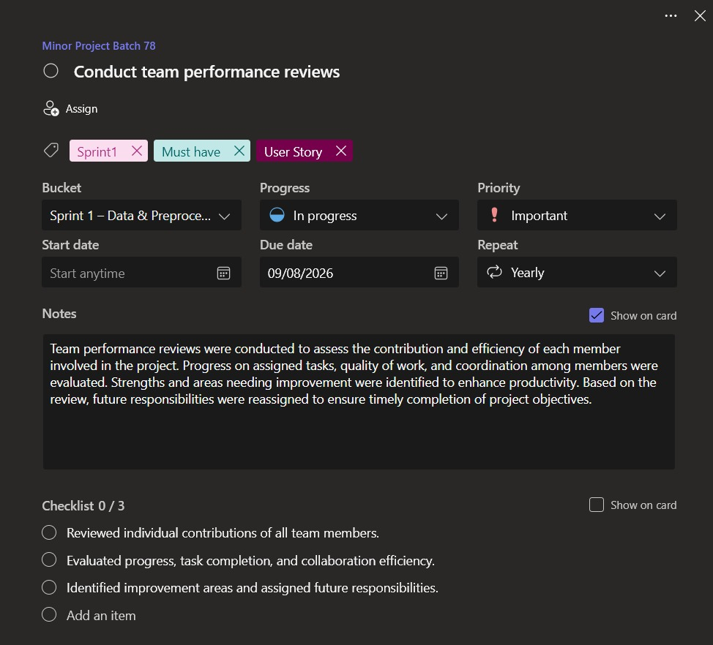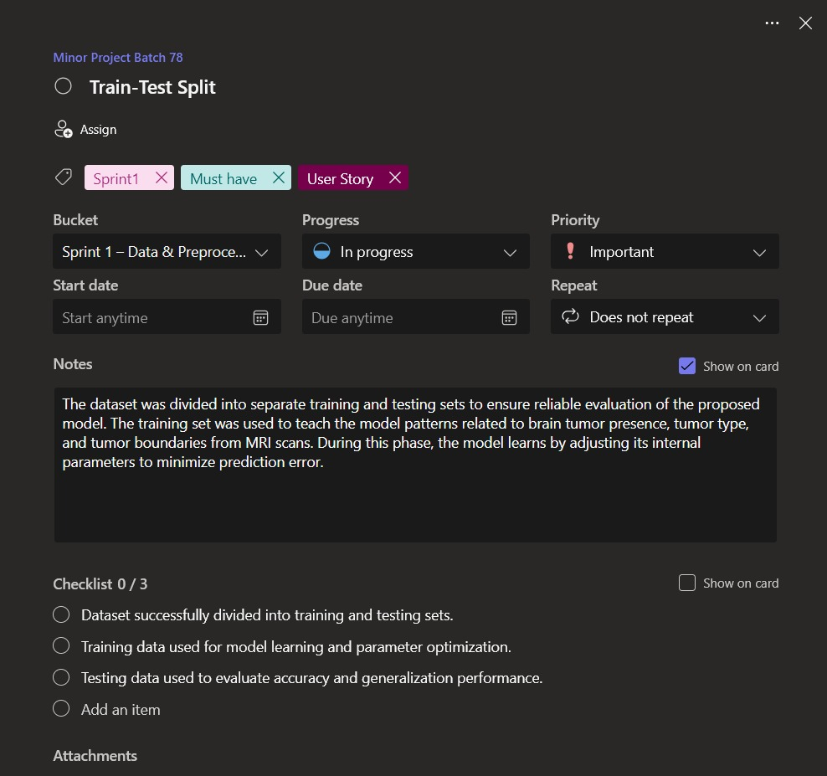

3.1.2 Functional Document
The functional document describes the core functionalities of the Real-Time Emergency Response System. It defines how the system behaves, the features it provides, and how different users interact with it. The system is designed to support multiple types of users including victims, responders, dispatchers, and hospitals, each having specific roles and responsibilities.

The system begins with a user authentication module, where users can register and log in securely. Based on the user role, appropriate access is provided to different features of the system. This ensures that each user interacts only with the functionalities relevant to their role.

One of the primary features of the system is the SOS alert module. In case of an emergency, the victim can trigger an SOS alert using a simple interface. Once activated, the system captures the user’s current location and sends it to the backend server. This alert is then forwarded to nearby responders and displayed on the dispatcher’s dashboard in real time.

The live tracking functionality is another key component of the system. After an alert is generated, the location of the victim is continuously tracked and updated using GPS. Responders can view this information on an integrated map interface, which helps them reach the location quickly and accurately. The system also tracks the responder’s movement to ensure proper coordination.

The system also includes a real-time communication module implemented using WebSocket technology. This allows instant communication between victims and responders through a chat interface. It enables users to share additional information, such as the nature of the emergency or specific instructions, thereby improving response effectiveness.

A dispatcher dashboard is provided to monitor and manage all ongoing emergencies. The dashboard displays active alerts, responder status, and location details in real time. Dispatchers can assign responders based on proximity and availability, ensuring optimal resource utilization.

In addition, the system provides a hospital coordination module, where hospitals receive notifications about incoming emergency cases. This allows medical staff to prepare in advance, reducing delays in treatment upon arrival of the patient.

The system is supported by a robust database management system, which stores user information, emergency records, and location data securely. Proper data handling mechanisms are implemented to ensure reliability, consistency, and security of information.

Overall, the functional components of the system work together to provide a seamless and efficient emergency response solution. The integration of real-time communication, tracking, and centralized management ensures quick decision-making and improved coordination among all stakeholders. 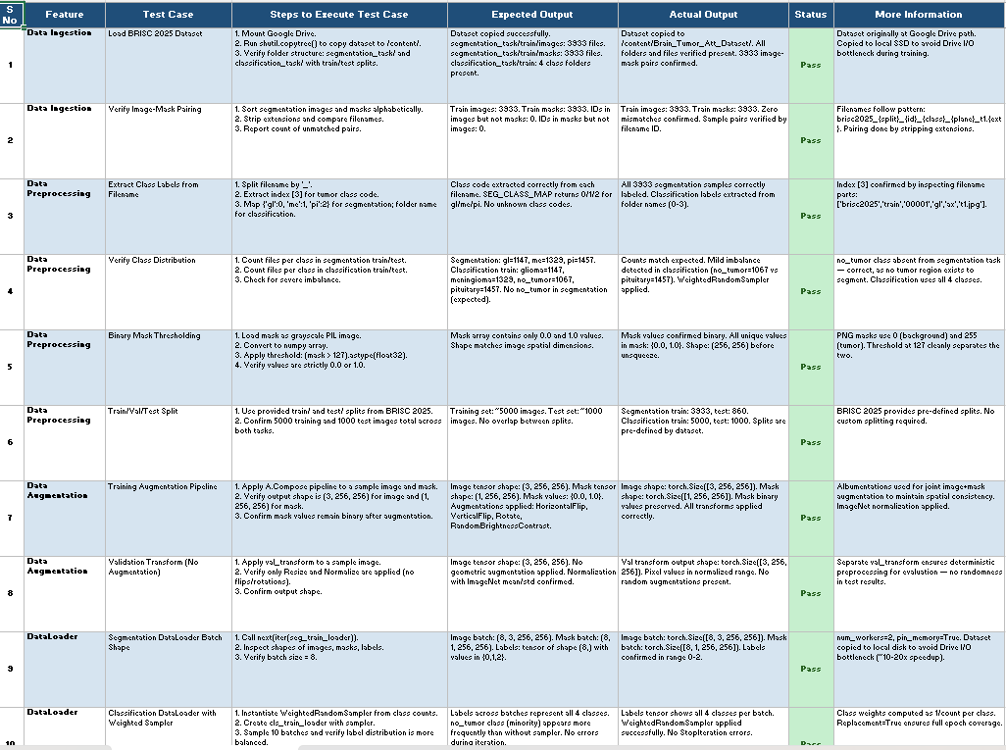

3.1.3 Architecture Document
The architecture of the Real-Time Emergency Response System is designed to ensure scalability, reliability, and efficient real-time communication. The system follows a client-server architecture, where different components are organized into layers to handle specific functionalities. This modular approach allows easy maintenance, better performance, and future enhancements.

The system primarily consists of four major components: Frontend Layer, Backend Layer, Database Layer, and Real-Time Communication Layer. These components interact with each other to provide a seamless emergency response experience.

The frontend layer is developed using modern web technologies and is responsible for user interaction. It provides an intuitive interface for victims, responders, dispatchers, and hospitals. Users can perform actions such as logging in, sending SOS alerts, viewing dashboards, tracking locations, and communicating through chat. The frontend communicates with the backend through RESTful APIs and WebSocket connections.

The backend layer is built using Node.js and Express, which handle all server-side operations. It processes user requests, manages application logic, and coordinates communication between different modules. The backend is responsible for handling authentication, emergency alert processing, responder assignment, and data synchronization. It acts as the central control unit of the system.

The database layer uses PostgreSQL to store and manage all system data. This includes user information, emergency requests, location data, and communication logs. The database is structured in a way that ensures efficient data retrieval and secure storage. Proper relationships are maintained between different entities to support system operations effectively.

The real-time communication layer is implemented using WebSocket technology through Socket.io. This layer enables instant data exchange between users and the server. Features such as live location tracking, real-time notifications, and chat communication are handled through this layer. It ensures minimal delay and continuous updates during emergency situations.

The interaction between these components follows a well-defined flow. When a user sends an SOS alert, the frontend captures the data and sends it to the backend. The backend processes the request, stores it in the database, and uses the real-time layer to notify responders and dispatchers. Responders can then track the victim’s location and communicate in real time.

This layered architecture ensures that each component performs its specific role efficiently while maintaining overall system performance. The design supports scalability, allowing the system to handle multiple users and emergency requests simultaneously. It also provides flexibility for future enhancements such as mobile integration and advanced analytics.

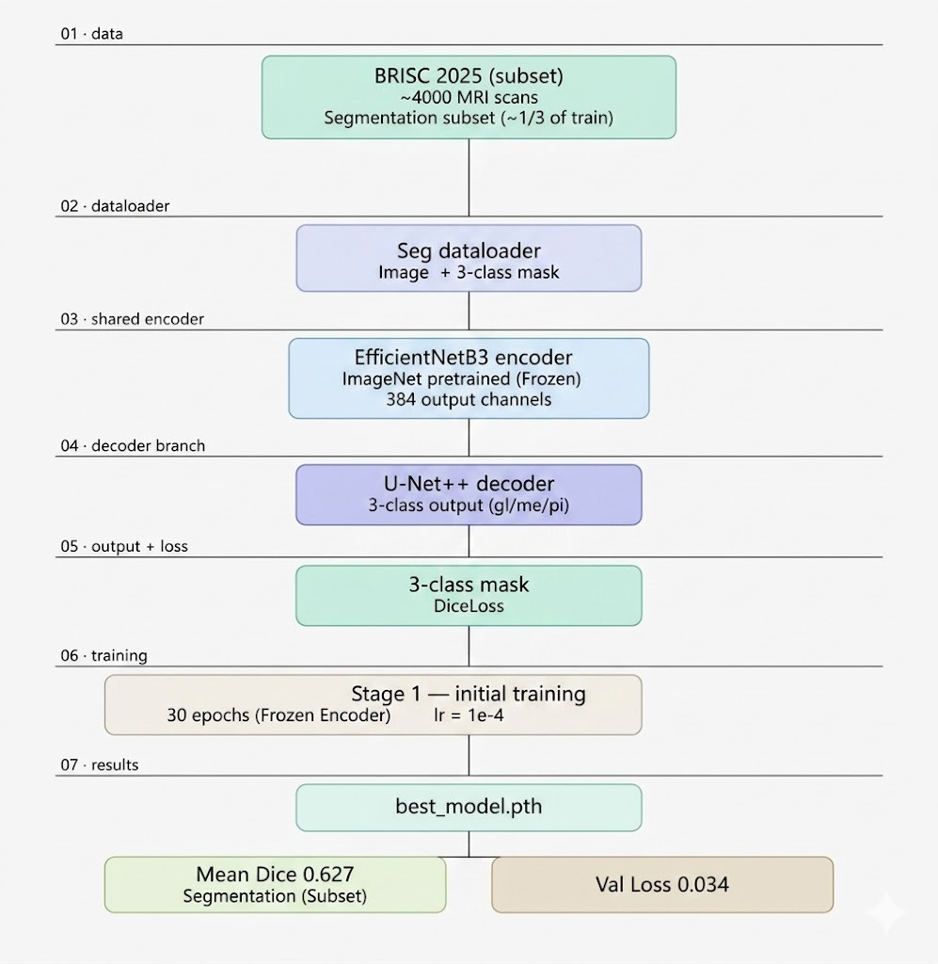

3.1.4 Outcome of objectives/ Result Analysis
The first sprint of the Real-Time Emergency Response System focused on establishing the foundational components required for the overall system. The primary objective of this sprint was to develop the core structure, including backend setup, database integration, and basic frontend interface.

By the end of Sprint I, the backend server was successfully implemented using Node.js and Express, enabling the system to handle API requests and manage application logic. The PostgreSQL database was designed and integrated to store user information and initial system data. This ensured that the system had a stable and reliable data management mechanism.

On the frontend side, a basic user interface was developed using React, providing essential components such as login and registration pages. The authentication module was implemented, allowing users to securely register and log in to the system. Role-based access control was also established to differentiate between various user types.

The sprint achieved its intended goals by successfully creating a working prototype of the system with core functionalities in place. The integration between frontend, backend, and database was verified, ensuring smooth communication between all components.

However, certain limitations were identified during this sprint. The system lacked real-time features such as live tracking and instant communication, which were planned for subsequent sprints. Additionally, the user interface required further improvements to enhance usability and responsiveness.

Overall, Sprint I provided a strong foundation for the project by establishing the essential building blocks of the system. The successful completion of this sprint ensured readiness for implementing advanced features such as real-time communication and emergency handling in the next phase.
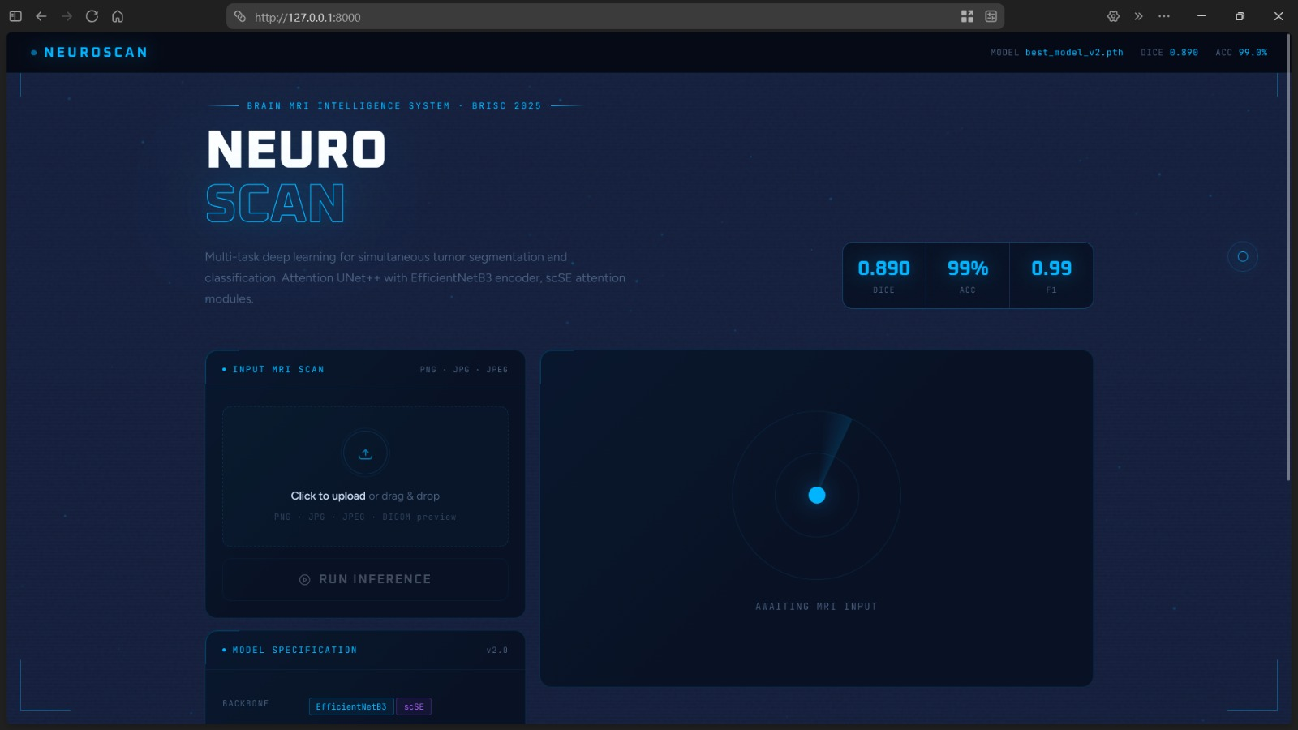

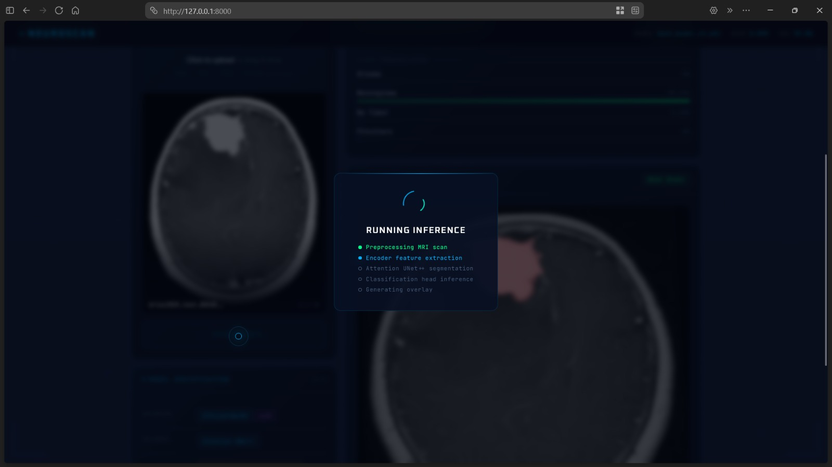

3.1.5 Sprint Retrospective
The Sprint I retrospective focuses on evaluating the development process, identifying strengths, and recognizing areas for improvement during the initial phase of the project. This sprint primarily dealt with setting up the core structure of the system, including backend development, database integration, and basic frontend implementation.

One of the key strengths of this sprint was the successful establishment of the system’s foundation. The backend server and database were integrated effectively, and the authentication module was implemented without major issues. The team was able to complete the planned tasks within the defined timeline, demonstrating good coordination and understanding of the project requirements.

However, certain challenges were encountered during the development process. Initial difficulties were faced in setting up the environment and ensuring proper communication between the frontend and backend. Some delays occurred due to debugging issues and handling errors in API integration. Additionally, the user interface developed in this sprint was basic and required further enhancement to improve usability and responsiveness.

Based on the observations, several improvements have been identified for future sprints. Better planning of tasks and more detailed division of responsibilities can help in reducing delays. Increased focus on testing during development can minimize debugging efforts later. Enhancing communication among team members and conducting regular reviews will also contribute to smoother execution.

Overall, Sprint I was successful in achieving its objectives and provided a strong foundation for the subsequent phases of the project. The insights gained from this retrospective will help in improving efficiency and performance in the upcoming sprints.

3.2 SPRINT II
3.2.1 Objectives with user stories of Sprint II
The objective of Sprint II is to implement the advanced and dynamic functionalities of the Real-Time Emergency Response System, with a primary focus on real-time communication, emergency alert handling, and live location tracking. This sprint aims to enhance the interactivity of the system and ensure that emergency situations are handled efficiently with minimal delay. The goal is to transform the basic system developed in Sprint I into a responsive and real-time platform capable of supporting instant communication and coordination among victims, responders, and dispatchers.

In this sprint, several critical user requirements are addressed to improve the functionality of the system. One of the key user stories focuses on the responder’s ability to receive emergency alerts in real time. As a responder, the user needs to be notified instantly whenever a victim sends an SOS alert so that immediate action can be taken. This feature ensures that alerts are delivered without delay, along with essential information such as the victim’s location and emergency details.

Another important user story involves live location tracking. As a responder, the user should be able to continuously track the victim’s location on a map interface. This functionality allows responders to monitor movement in real time and choose the most efficient route to reach the victim. Continuous updates of location data ensure accuracy and reduce the time required to reach the emergency site.

The sprint also includes a user story related to real-time communication between victims and responders. As a victim, the user should be able to communicate with the assigned responder through a chat interface. This enables the victim to share additional details about the emergency, such as the severity of the situation or specific instructions. Similarly, responders can provide guidance and reassurance while enroute, improving coordination and response effectiveness.

Overall, Sprint II focuses on integrating real-time capabilities into the system, significantly enhancing its functionality and responsiveness. The successful implementation of these user stories ensures that the system can effectively handle emergency situations with improved speed, accuracy, and coordination.

S.NO | Detailed User Stories
US #1 | As a responder, I want to receive SOS alerts instantly so that I can respond to emergencies without delay. This feature enables the system to push emergency alerts in real time to all available responders when a victim triggers an SOS..
US #2 | As a responder, I want to track the victim’s live location so that I can reach them quickly and accurately. This feature allows continuous tracking of the victim’s location using GPS.
US #3 | As a victim, I want to communicate with the responder through chat so that I can provide additional details about my emergency. This feature enables a real-time messaging system between victims and responders.
US #4 | As a dispatcher, I want to monitor all ongoing emergencies so that I can manage and assign responders efficiently. This feature provides a centralized dashboard that displays all active emergency alerts, responder availability, and live location updates.

3.2.2 Functional Document
The functional document for Sprint II focuses on implementing the advanced features of the Real-Time Emergency Response System, particularly those related to real-time communication, live tracking, and emergency management. This sprint enhances the system developed in the previous phase by introducing dynamic functionalities that enable faster and more efficient handling of emergency situations.

One of the key functionalities introduced in this sprint is the real-time SOS alert notification system. When a victim triggers an emergency alert, the system processes the request and instantly notifies all available responders through the real-time communication layer. The alert includes essential information such as the victim’s identity and current location, ensuring that responders can take immediate action without delay.

Another important functionality is the live location tracking module. Once an SOS alert is activated, the system continuously captures and updates the victim’s GPS location. This information is transmitted to the responders and displayed on a map interface, allowing them to track the victim’s movement in real time. This feature significantly improves response accuracy and reduces the time required to reach the emergency location.

3.2.3 Architecture Document
The architecture for Sprint II of the Real-Time Emergency Response System focuses on integrating real-time communication, live tracking, and dynamic data flow into the existing system developed in Sprint I. This phase enhances the overall architecture by introducing a real-time interaction layer that enables instant communication and continuous updates between different system components.

The backend layer plays a crucial role in managing real-time events. It processes incoming SOS alerts, handles user requests, and coordinates communication between victims, responders, and dispatchers. The backend integrates with the Socket.io framework to enable event-driven communication, allowing instant transmission of alerts, messages, and location updates.

A significant enhancement in this sprint is the real-time communication layer, which is implemented using WebSocket technology. This layer ensures that data such as SOS alerts, chat messages, and location updates are transmitted instantly without the need for repeated requests. It supports bidirectional communication, enabling both the server and clients to send and receive data in real time.

The live tracking architecture is designed to continuously capture the victim’s location using GPS and send periodic updates to the server. These updates are then broadcast to responders and displayed on a map interface in the frontend. This ensures accurate and up-to-date location tracking throughout the emergency.
The database layer continues to store essential information such as emergency alerts, user data, and communication logs. It works in coordination with the backend to ensure that all real-time events are properly recorded and can be retrieved when needed.

The overall data flow in this architecture begins when a victim triggers an SOS alert. The frontend sends the alert to the backend, which processes and stores the information in the database. The real-time layer then broadcasts the alert to responders and dispatchers. Responders can track the victim’s location and communicate through the chat system, all of which are handled through the integrated architecture.
This enhanced architecture ensures low latency, high responsiveness, and efficient handling of multiple simultaneous events. It provides a robust foundation for real-time emergency management. 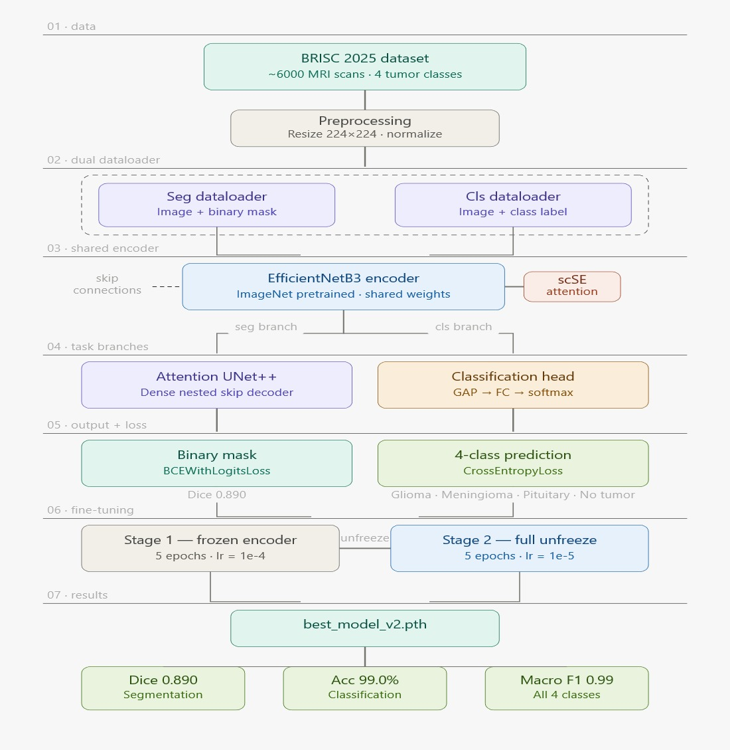

3.2.4 Outcome of objectives/ Result Analysis
The Sprint II retrospective focuses on evaluating the development process of advanced features such as real-time communication, live tracking, and emergency alert handling. This sprint aimed to enhance the system by making it more interactive and responsive to real-time events.

One of the major achievements of this sprint was the successful implementation of real-time functionalities using WebSocket technology. The system was able to deliver SOS alerts instantly to responders and dispatchers, significantly improving response time. The live location tracking feature also performed effectively, allowing responders to monitor the victim’s position continuously. Additionally, the chat system enabled seamless communication between users, improving coordination during emergencies.

Despite these achievements, certain challenges were encountered during the sprint. Integrating real-time communication with the existing system required careful handling of events and data synchronization. Minor delays were observed in location updates under unstable network conditions, and debugging real-time features was more complex compared to static functionalities. Ensuring smooth interaction between frontend and backend components also required additional effort.

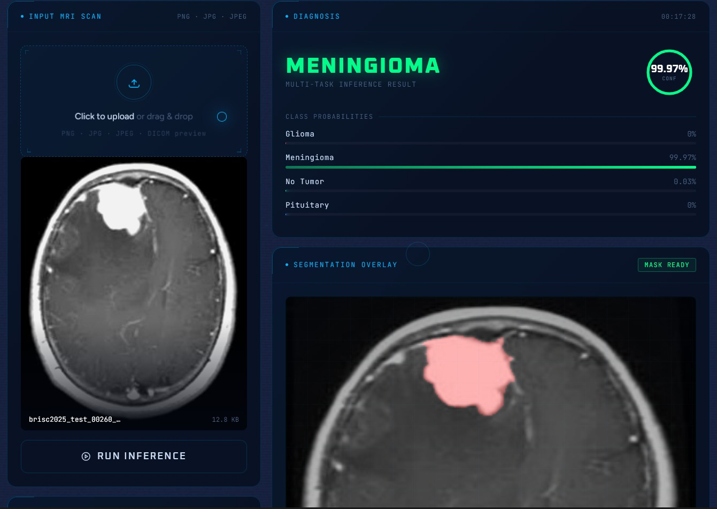

3.2.5 Sprint Retrospective
The Sprint II retrospective focuses on evaluating the development process of advanced features such as real-time communication, live tracking, and emergency alert handling. This sprint aimed to enhance the system by making it more interactive and responsive to real-time events.

One of the major achievements of this sprint was the successful implementation of real-time functionalities using WebSocket technology. The system was able to deliver SOS alerts instantly to responders and dispatchers, significantly improving response time. The live location tracking feature also performed effectively, allowing responders to monitor the victim’s position continuously. Additionally, the chat system enabled seamless communication between users, improving coordination during emergencies.

Despite these achievements, certain challenges were encountered during the sprint. Integrating real-time communication with the existing system required careful handling of events and data synchronization. Minor delays were observed in location updates under unstable network conditions, and debugging real-time features was more complex compared to static functionalities. Ensuring smooth interaction between frontend and backend components also required additional effort.

Based on the observations, several improvements have been identified for future development. Optimizing real-time data handling and improving network efficiency can enhance system performance. Better testing strategies, especially for real-time scenarios, can help in identifying issues earlier. Enhancing the user interface for real-time features will also improve overall user experience.

Overall, Sprint II was successful in achieving its objectives and significantly improved the functionality of the system. The lessons learned from this sprint will help in refining the development process and implementing more advanced features in the subsequent phases.

CHAPTER 4
RESULTS AND DISCUSSIONS

The Real-Time Emergency Response System was successfully developed and tested to evaluate its performance and effectiveness in handling emergency situations. The system was able to perform all core functionalities as intended, including user authentication, SOS alert generation, real-time communication, and live location tracking.

During testing, the SOS alert feature demonstrated immediate response by sending alerts to responders and dispatchers without noticeable delay. The integration of WebSocket technology enabled real-time notifications, ensuring that emergency requests were received instantly. This significantly improved the speed of communication compared to traditional methods.

The live location tracking feature also produced accurate and continuous updates of the victim’s position. Responders were able to view the location on a map interface and navigate efficiently to the emergency site. The system maintained consistency in location updates under normal network conditions.

The Real-Time Emergency Response System was successfully developed and tested to evaluate its performance and effectiveness in handling emergency situations. The system was able to perform all core functionalities as intended, including user authentication, SOS alert generation, real-time communication, and live location tracking.

During testing, the SOS alert feature demonstrated immediate response by sending alerts to responders and dispatchers without noticeable delay. The integration of WebSocket technology enabled real-time notifications, ensuring that emergency requests were received instantly. This significantly improved the speed of communication compared to traditional methods.

The live location tracking feature also produced accurate and continuous updates of the victim’s position. Responders were able to view the location on a map interface and navigate efficiently to the emergency site. The system maintained consistency in location updates under normal network conditions.

The real-time chat functionality allowed seamless communication between victims and responders. Messages were delivered instantly, enabling users to exchange critical information during emergencies. This feature improved coordination and ensured better understanding of the situation.

The dispatcher dashboard provided a centralized view of all ongoing emergencies. It displayed real-time updates, including alert status, responder availability, and location data. This allowed efficient monitoring and management of multiple emergency cases simultaneously.

CONCLUSION AND FUTURE ENHANCEMENT:

The Real-Time Emergency Response System developed in this project successfully demonstrates how modern web technologies can be utilized to improve emergency management and response efficiency. The system provides an integrated platform that connects victims, responders, dispatchers, and hospitals, enabling seamless communication and coordination during critical situations.
The implementation of features such as SOS alert generation, live location tracking, and real-time communication significantly enhances the speed and accuracy of emergency response. By leveraging WebSocket technology, the system ensures instant transmission of alerts and messages, reducing delays commonly associated with traditional emergency systems. The centralized dashboard further improves the ability to monitor and manage multiple emergency cases effectively.
The project achieved its primary objectives by developing a scalable and user-friendly system capable of handling real-time interactions. The integration of frontend, backend, database, and real-time communication layers was successfully accomplished, resulting in a reliable and efficient application.
Although certain limitations exist, such as dependency on internet connectivity and minor delays under unstable network conditions, the overall performance of the system demonstrates its potential as a practical solution for modern emergency response. The project highlights the importance of adopting advanced technologies to address real-world challenges and improve public safety.
In conclusion, the developed system provides a strong foundation for building smarter and more responsive emergency management solutions, with the potential to significantly reduce response time and improve outcomes in critical situations.

Future Enhancements
The current system can be further enhanced by integrating advanced technologies and expanding its capabilities. Future improvements may include the development of a mobile application to increase accessibility and usability for a wider range of users.
The integration of artificial intelligence can be explored to enable predictive analysis and intelligent decision-making, such as identifying high-risk areas or prioritizing emergency requests. Additionally, incorporating offline functionality or alternative communication methods can help address the limitations related to internet dependency.
Further enhancements may include integration with government emergency services and the addition of advanced analytics dashboards to monitor system performance and generate insights. Improving security features and optimizing real-time data handling will also contribute to making the system more robust and reliable.

REFERENCES

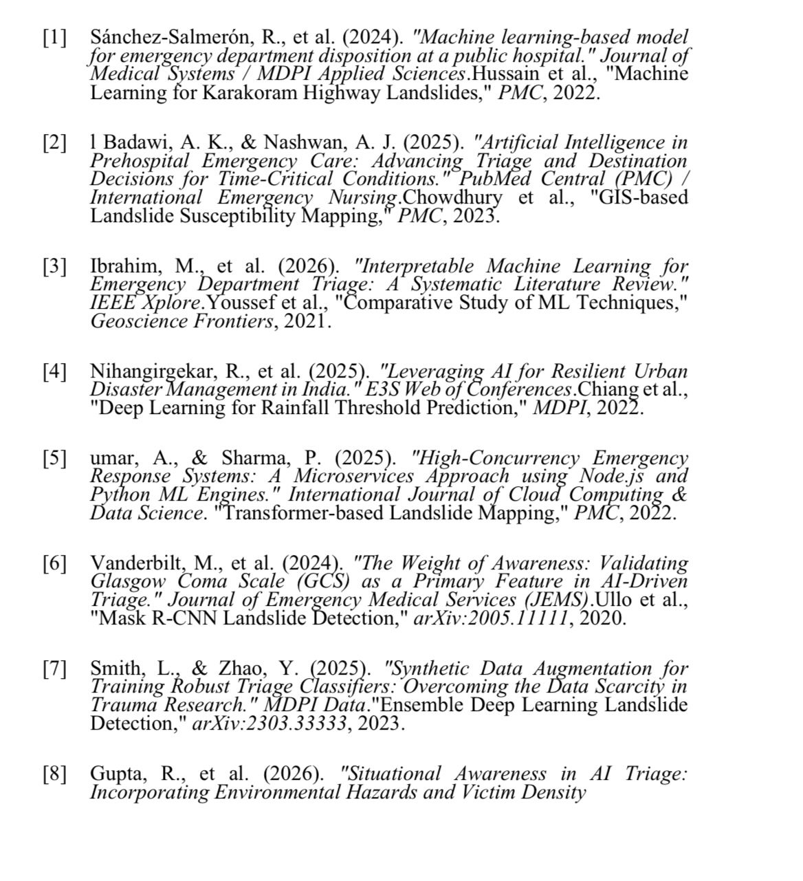

APPENDIX A

CODING

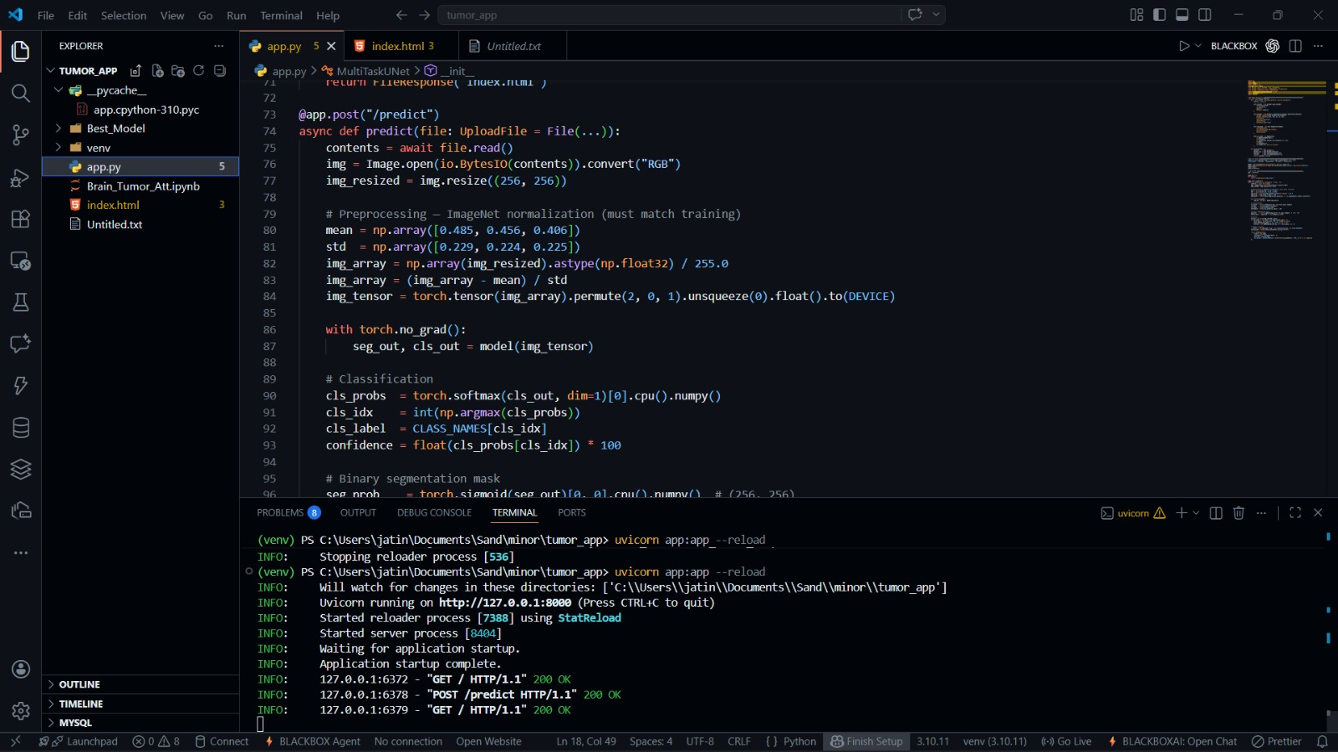

App.py:

import io
import cv2
import torch
import numpy as np
from PIL import Image
from fastapi import FastAPI, File, UploadFile
from fastapi.responses import JSONResponse, FileResponse
from fastapi.staticfiles import StaticFiles
import segmentation_models_pytorch as smp
import torch.nn as nn
import base64

# ── Model definition ─────────────────────────────────────────────────────────
class MultiTaskUNet(nn.Module):
def __init__(self, num_seg_classes=1, num_cls_classes=4):
super().__init__()

self.encoder = smp.encoders.get_encoder(
"efficientnet-b3",
in_channels=3,
depth=5,
weights="imagenet"
)

self.decoder = smp.decoders.unetplusplus.decoder.UnetPlusPlusDecoder(
encoder_channels=self.encoder.out_channels,
decoder_channels=(256, 128, 64, 32, 16),
n_blocks=5,
use_norm='batchnorm',
center=False,
attention_type="scse"
)

self.seg_head = smp.base.SegmentationHead(
in_channels=16,
out_channels=num_seg_classes,
activation=None,
kernel_size=3
)

self.cls_head = nn.Sequential(
nn.AdaptiveAvgPool2d(1),
nn.Flatten(),
nn.Linear(self.encoder.out_channels[-1], 128),
nn.ReLU(),
nn.Dropout(0.3),
nn.Linear(128, num_cls_classes)
)

def forward(self, x):
features = self.encoder(x)
decoder_out = self.decoder(features)
seg_mask = self.seg_head(decoder_out)
cls_out = self.cls_head(features[-1])
return seg_mask, cls_out

# ── Load model ───────────────────────────────────────────────────────────────
DEVICE = torch.device("cuda" if torch.cuda.is_available() else "cpu")
CLASS_NAMES = ["glioma", "meningioma", "no_tumor", "pituitary"]

model = MultiTaskUNet(num_seg_classes=1, num_cls_classes=4)
model.load_state_dict(torch.load("Best_Model/best_model_v2.pth", map_location=DEVICE))
model.eval()
model.to(DEVICE)

# ── FastAPI ──────────────────────────────────────────────────────────────────
app = FastAPI()

@app.get("/")
def index():
return FileResponse("index.html")

@app.post("/predict")
async def predict(file: UploadFile = File(...)):
contents = await file.read()
img = Image.open(io.BytesIO(contents)).convert("RGB")
img_resized = img.resize((256, 256))

# Preprocessing — ImageNet normalization (must match training)
mean = np.array([0.485, 0.456, 0.406])
std = np.array([0.229, 0.224, 0.225])
img_array = np.array(img_resized).astype(np.float32) / 255.0
img_array = (img_array - mean) / std
img_tensor = torch.tensor(img_array).permute(2, 0, 1).unsqueeze(0).float().to(DEVICE)

with torch.no_grad():
seg_out, cls_out = model(img_tensor)

# Classification
cls_probs = torch.softmax(cls_out, dim=1)[0].cpu().numpy()
cls_idx = int(np.argmax(cls_probs))
cls_label = CLASS_NAMES[cls_idx]
confidence = float(cls_probs[cls_idx]) * 100

# Binary segmentation mask
seg_prob = torch.sigmoid(seg_out)[0, 0].cpu().numpy() # (256, 256)
binary_mask = (seg_prob > 0.5).astype(np.uint8)

# Overlay
overlay = np.array(img_resized).copy()
if cls_label != "no_tumor" and binary_mask.sum() > 0:
color_mask = np.zeros((256, 256, 3), dtype=np.uint8)
color_mask[binary_mask == 1] = [255, 0, 0] # red
overlay = cv2.addWeighted(overlay, 0.7, color_mask, 0.3, 0)

# Encode to base64
_, buffer = cv2.imencode(".png", cv2.cvtColor(overlay, cv2.COLOR_RGB2BGR))
overlay_b64 = base64.b64encode(buffer).decode("utf-8")

return JSONResponse({
"label": cls_label,
"confidence": round(confidence, 2),
"overlay": overlay_b64,
"all_probs": {CLASS_NAMES[i]: round(float(cls_probs[i]) * 100, 2) for i in range(4)}
})

Index.html

<!DOCTYPE html>
<html lang="en">

<head>
<meta charset="UTF-8">
<meta name="viewport" content="width=device-width, initial-scale=1.0">
<title>NeuroScan · Advanced MRI Intelligence</title>
<link rel="preconnect" href="https://fonts.googleapis.com">
<link
href="https://fonts.googleapis.com/css2?family=Oxanium:wght@300;400;500;600;700;800&family=JetBrains+Mono:wght@300;400;500;700&family=Figtree:wght@300;400;500;600&display=swap"
rel="stylesheet">
<style>
:root {
--bg: #141f3e;
--bg2: #18294f;
--panel: rgba(8, 16, 35, 0.92);
--panel2: rgba(10, 20, 45, 0.85);
--border: rgba(0, 180, 255, 0.08);
--border-hi: rgba(0, 180, 255, 0.18);
--border-glow: rgba(0, 180, 255, 0.45);
--cyan: #00b4ff;
--cyan-dim: rgba(0, 180, 255, 0.6);
--teal: #00ffd5;
--purple: #a855f7;
--red: #ff4d6d;
--green: #00ff88;
--blue: #4d9fff;
--amber: #fbbf24;
--text: #c8d8f0;
--text-dim: #4a6080;
--mono: 'JetBrains Mono', monospace;
--display: 'Oxanium', sans-serif;
--body: 'Figtree', sans-serif;
--glow-cyan: 0 0 20px rgba(0, 180, 255, 0.4);
--glow-red: 0 0 20px rgba(255, 77, 109, 0.5);
--glow-green: 0 0 20px rgba(0, 255, 136, 0.4);
--glow-purple: 0 0 20px rgba(168, 85, 247, 0.4);
}

*,
*::before,
*::after {
box-sizing: border-box;
margin: 0;
padding: 0;
}

html {
scroll-behavior: smooth;
overflow-x: hidden;
}

body {
font-family: var(--body);
background: var(--bg);
color: var(--text);
min-height: 100vh;
overflow-x: hidden;
cursor: none;
}

/* ── CUSTOM CURSOR ── */
#cursor {
position: fixed;
width: 12px;
height: 12px;
border: 1.5px solid var(--cyan);
border-radius: 50%;
pointer-events: none;
z-index: 9999;
transform: translate(-50%, -50%);
transition: width 0.2s, height 0.2s, background 0.2s;
box-shadow: var(--glow-cyan);
}

#cursor-trail {
position: fixed;
width: 36px;
height: 36px;
border: 1px solid rgba(0, 180, 255, 0.2);
border-radius: 50%;
pointer-events: none;
z-index: 9998;
transform: translate(-50%, -50%);
transition: left 0.12s ease, top 0.12s ease;
}

body:has(button:hover) #cursor,
body:has(label:hover) #cursor,
body:has(.upload-zone:hover) #cursor {
width: 20px;
height: 20px;
background: rgba(0, 180, 255, 0.15);
}

/* ── CANVAS BACKGROUND ── */
#bgCanvas {
position: fixed;
inset: 0;
z-index: 0;
opacity: 0.6;
}

/* ── NOISE GRAIN ── */
.grain {
position: fixed;
inset: -50%;
width: 200%;
height: 200%;
background-image: url("data:image/svg+xml,%3Csvg viewBox='0 0 512 512' xmlns='http://www.w3.org/2000/svg'%3E%3Cfilter id='n'%3E%3CfeTurbulence type='fractalNoise' baseFrequency='0.75' numOctaves='4' stitchTiles='stitch'/%3E%3C/filter%3E%3Crect width='100%25' height='100%25' filter='url(%23n)' opacity='1'/%3E%3C/svg%3E");
pointer-events: none;
z-index: 1;
opacity: 0.028;
animation: grainShift 0.5s steps(2) infinite;
}

@keyframes grainShift {
0% {
transform: translate(0, 0);
}

25% {
transform: translate(-2%, 1%);
}

50% {
transform: translate(1%, -1%);
}

75% {
transform: translate(2%, 2%);
}

100% {
transform: translate(-1%, -2%);
}
}

/* ── SCANLINES ── */
.scanlines {
position: fixed;
inset: 0;
background: repeating-linear-gradient(0deg, transparent, transparent 3px,
rgba(0, 0, 0, 0.06) 3px, rgba(0, 0, 0, 0.06) 4px);
pointer-events: none;
z-index: 2;
}

/* ── HUD CORNERS ── */
.hud-corner {
position: fixed;
width: 60px;
height: 60px;
pointer-events: none;
z-index: 3;
opacity: 0.4;
}

.hud-corner.tl {
top: 16px;
left: 16px;
border-top: 1px solid var(--cyan);
border-left: 1px solid var(--cyan);
}

.hud-corner.tr {
top: 16px;
right: 16px;
border-top: 1px solid var(--cyan);
border-right: 1px solid var(--cyan);
}

.hud-corner.bl {
bottom: 16px;
left: 16px;
border-bottom: 1px solid var(--cyan);
border-left: 1px solid var(--cyan);
}

.hud-corner.br {
bottom: 16px;
right: 16px;
border-bottom: 1px solid var(--cyan);

border-right: 1px solid var(--cyan);
}

/* ── TOP BAR ── */
.topbar {
position: fixed;
top: 0;
left: 0;
right: 0;
height: 48px;
z-index: 100;
background: rgba(3, 6, 15, 0.85);
backdrop-filter: blur(16px);
border-bottom: 1px solid var(--border);
display: flex;
align-items: center;
justify-content: space-between;
padding: 0 28px;
}

.topbar-logo {
font-family: var(--display);
font-size: 1rem;
font-weight: 700;
letter-spacing: 0.2em;
color: var(--cyan);
text-shadow: var(--glow-cyan);
display: flex;
align-items: center;
gap: 8px;
}

APPENDIX B

CONFERENCE PRESENTATION

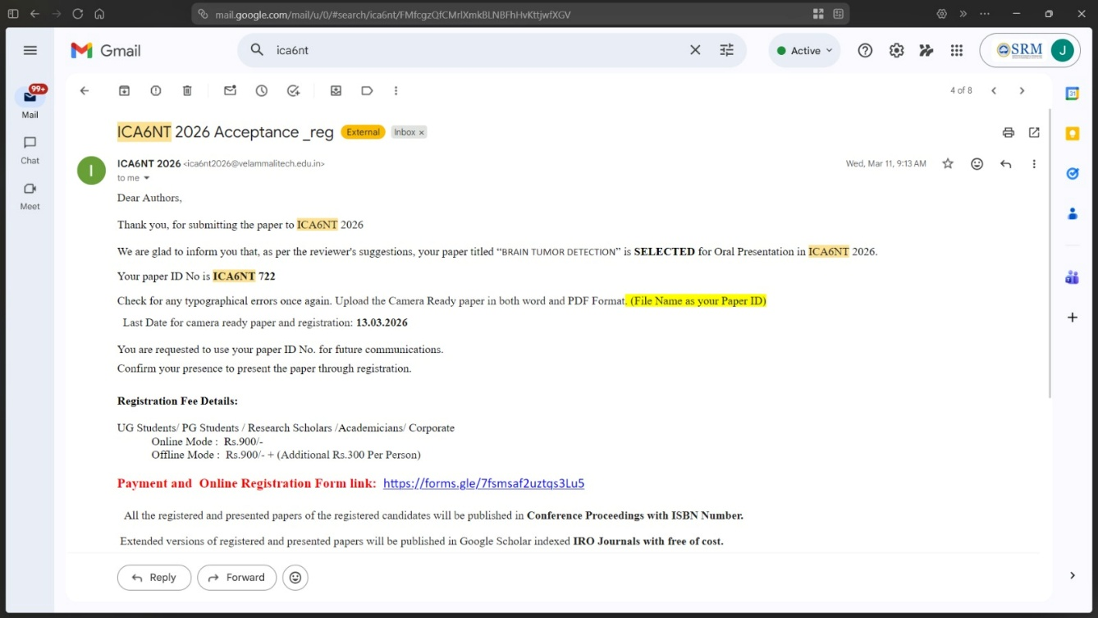

APPENDIX C

PUBLICATION DETAILS

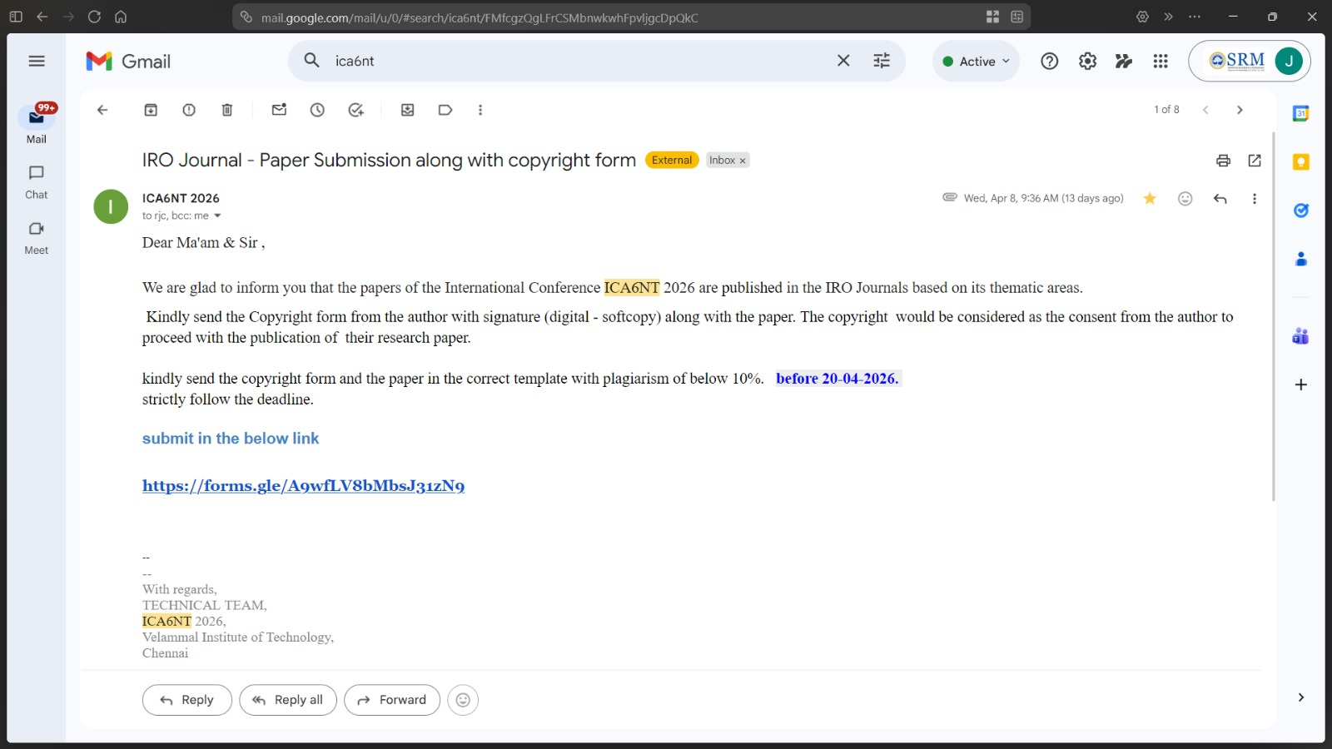
APPENDIX D
PLAGIARISM REPORT
